*Project 1 - USA Crime Analysis*

1.Write a mapreduce/pig program to calculate the number of cases investigated under each FBI code.

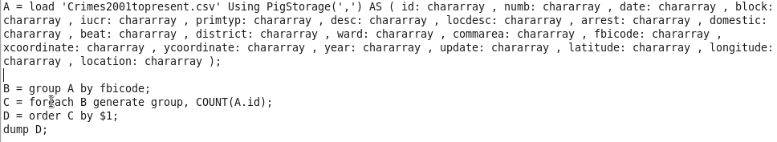

Output:

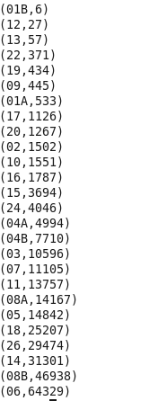

2.Write a mapreduce/pig program to calculate the number of cases investigated under FBI code 32.

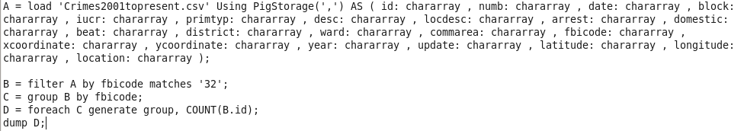

Output:



3.Write a mapreduce/pig program to calculate the number of arrests in theft district wise.

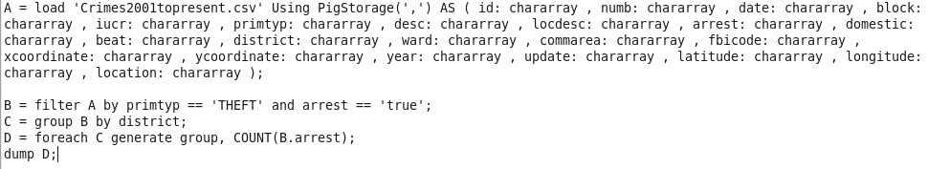

Output:

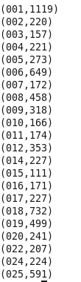

4) Write a mapreduce/pig program to calculate the number of arrests done between october 2014 and october 2015.

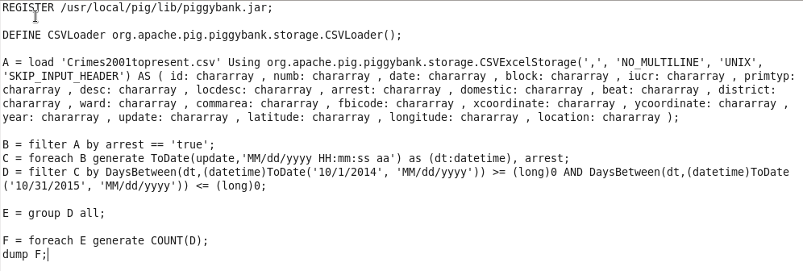

Output:

